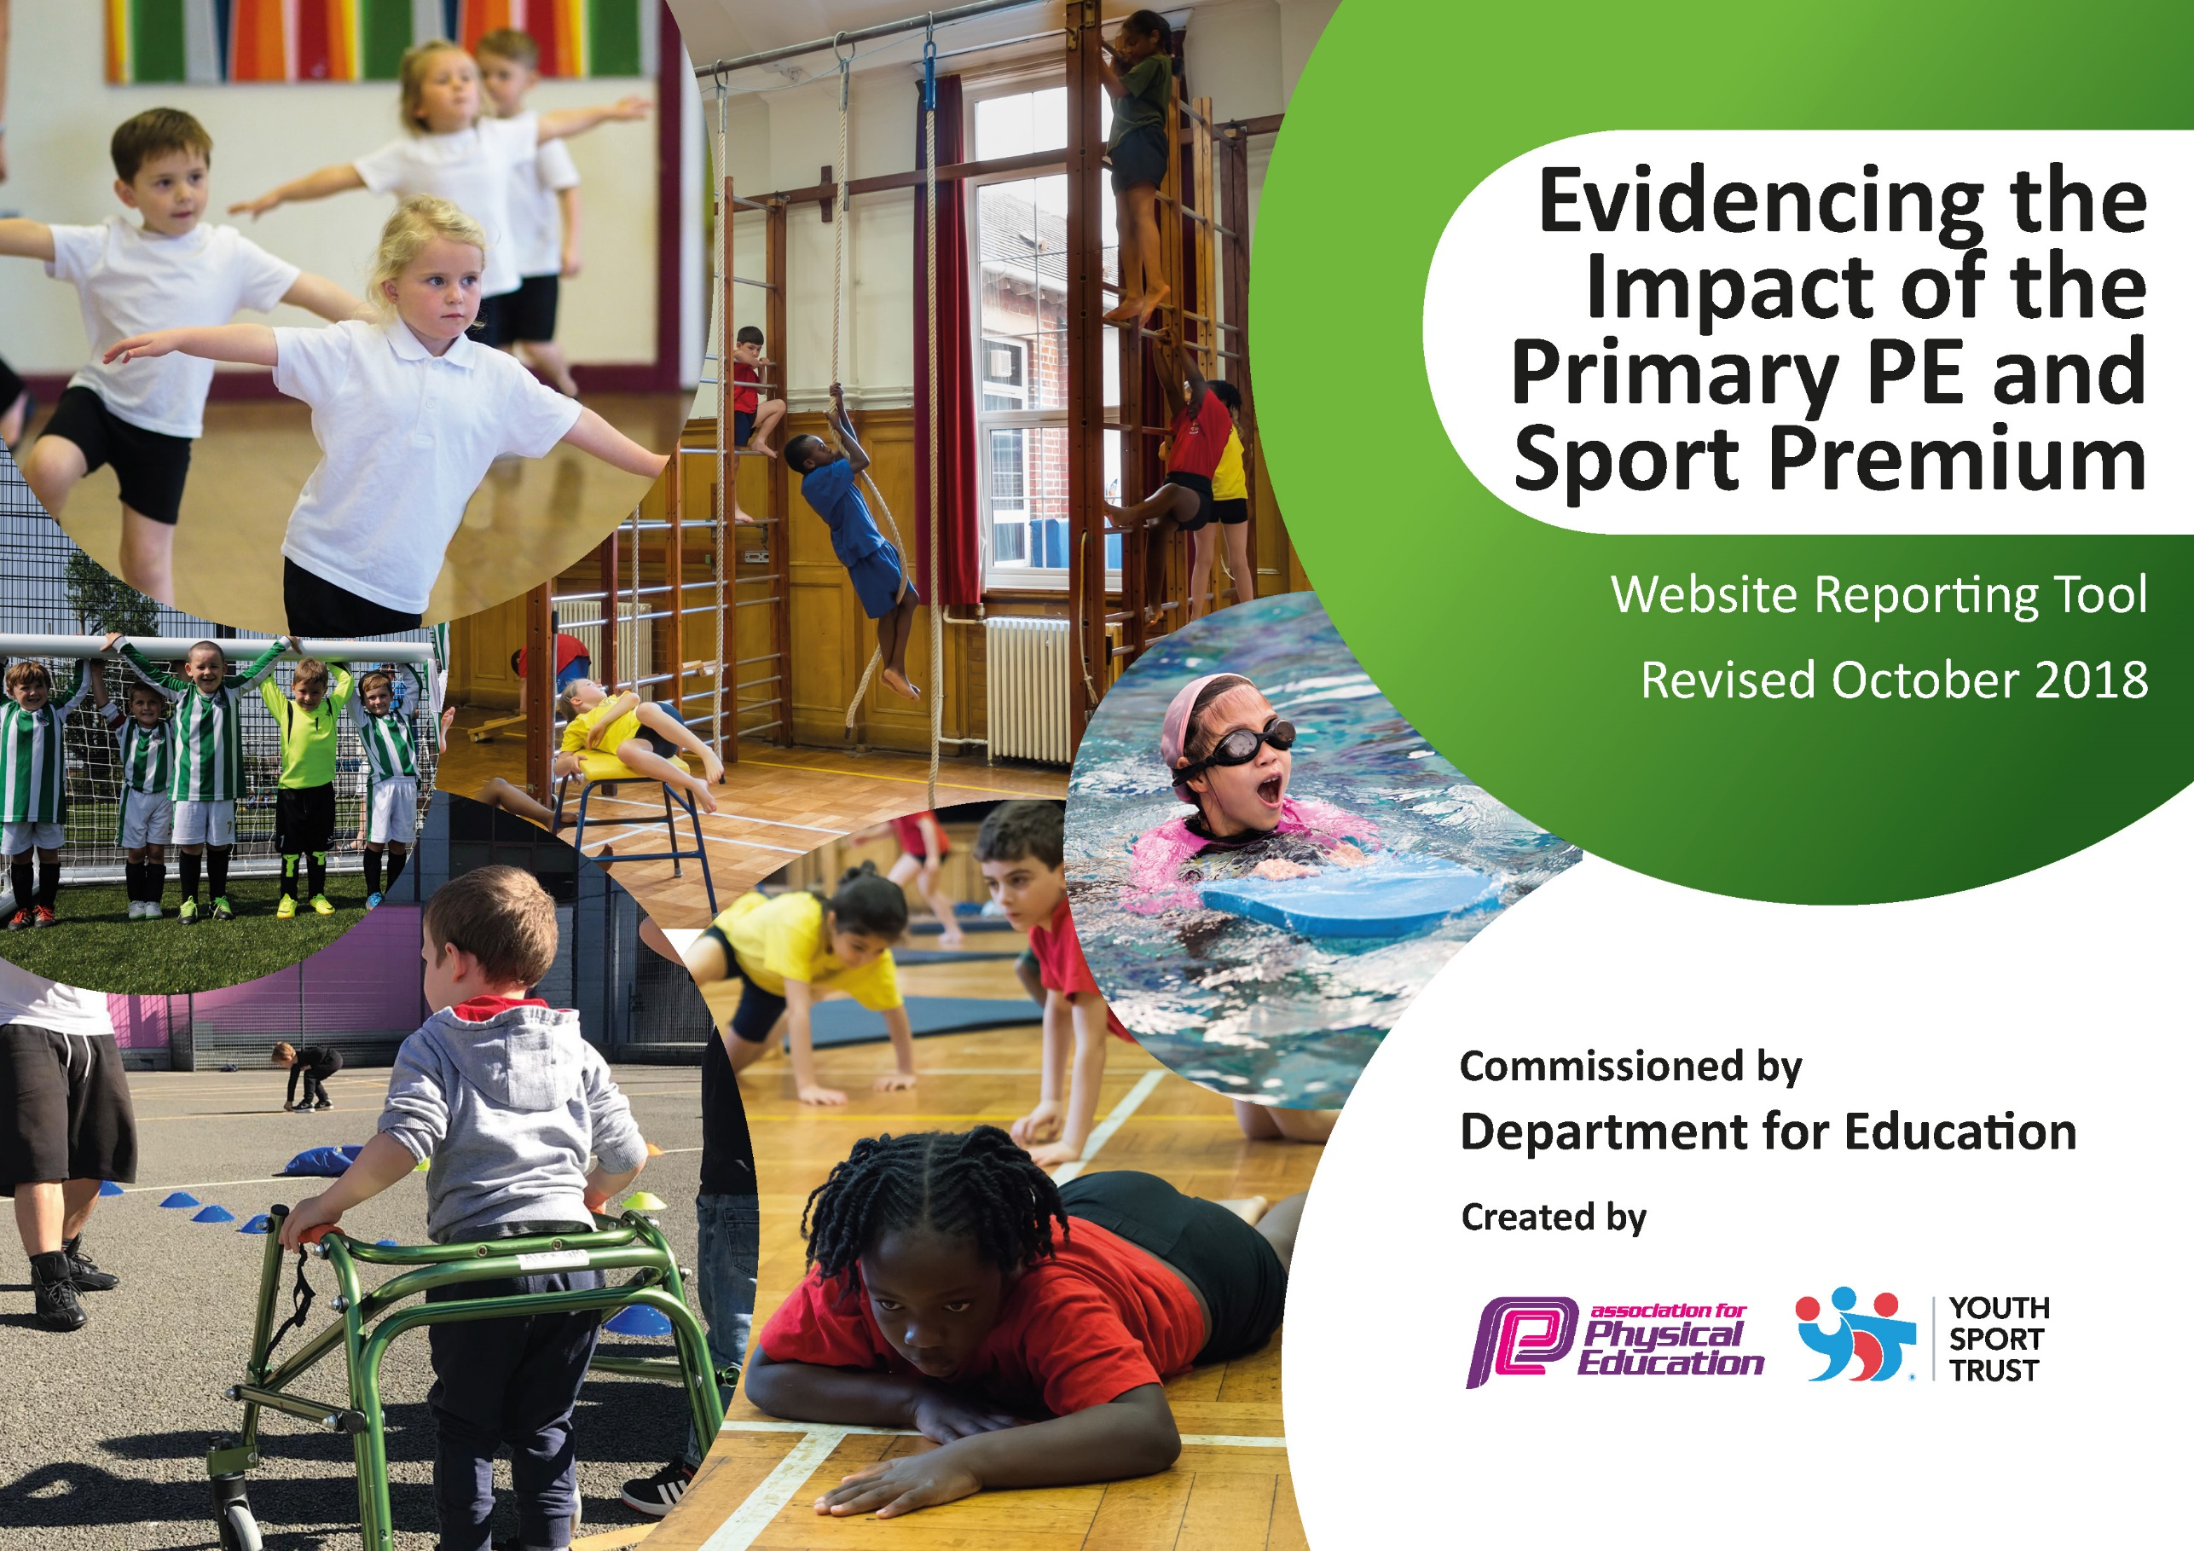
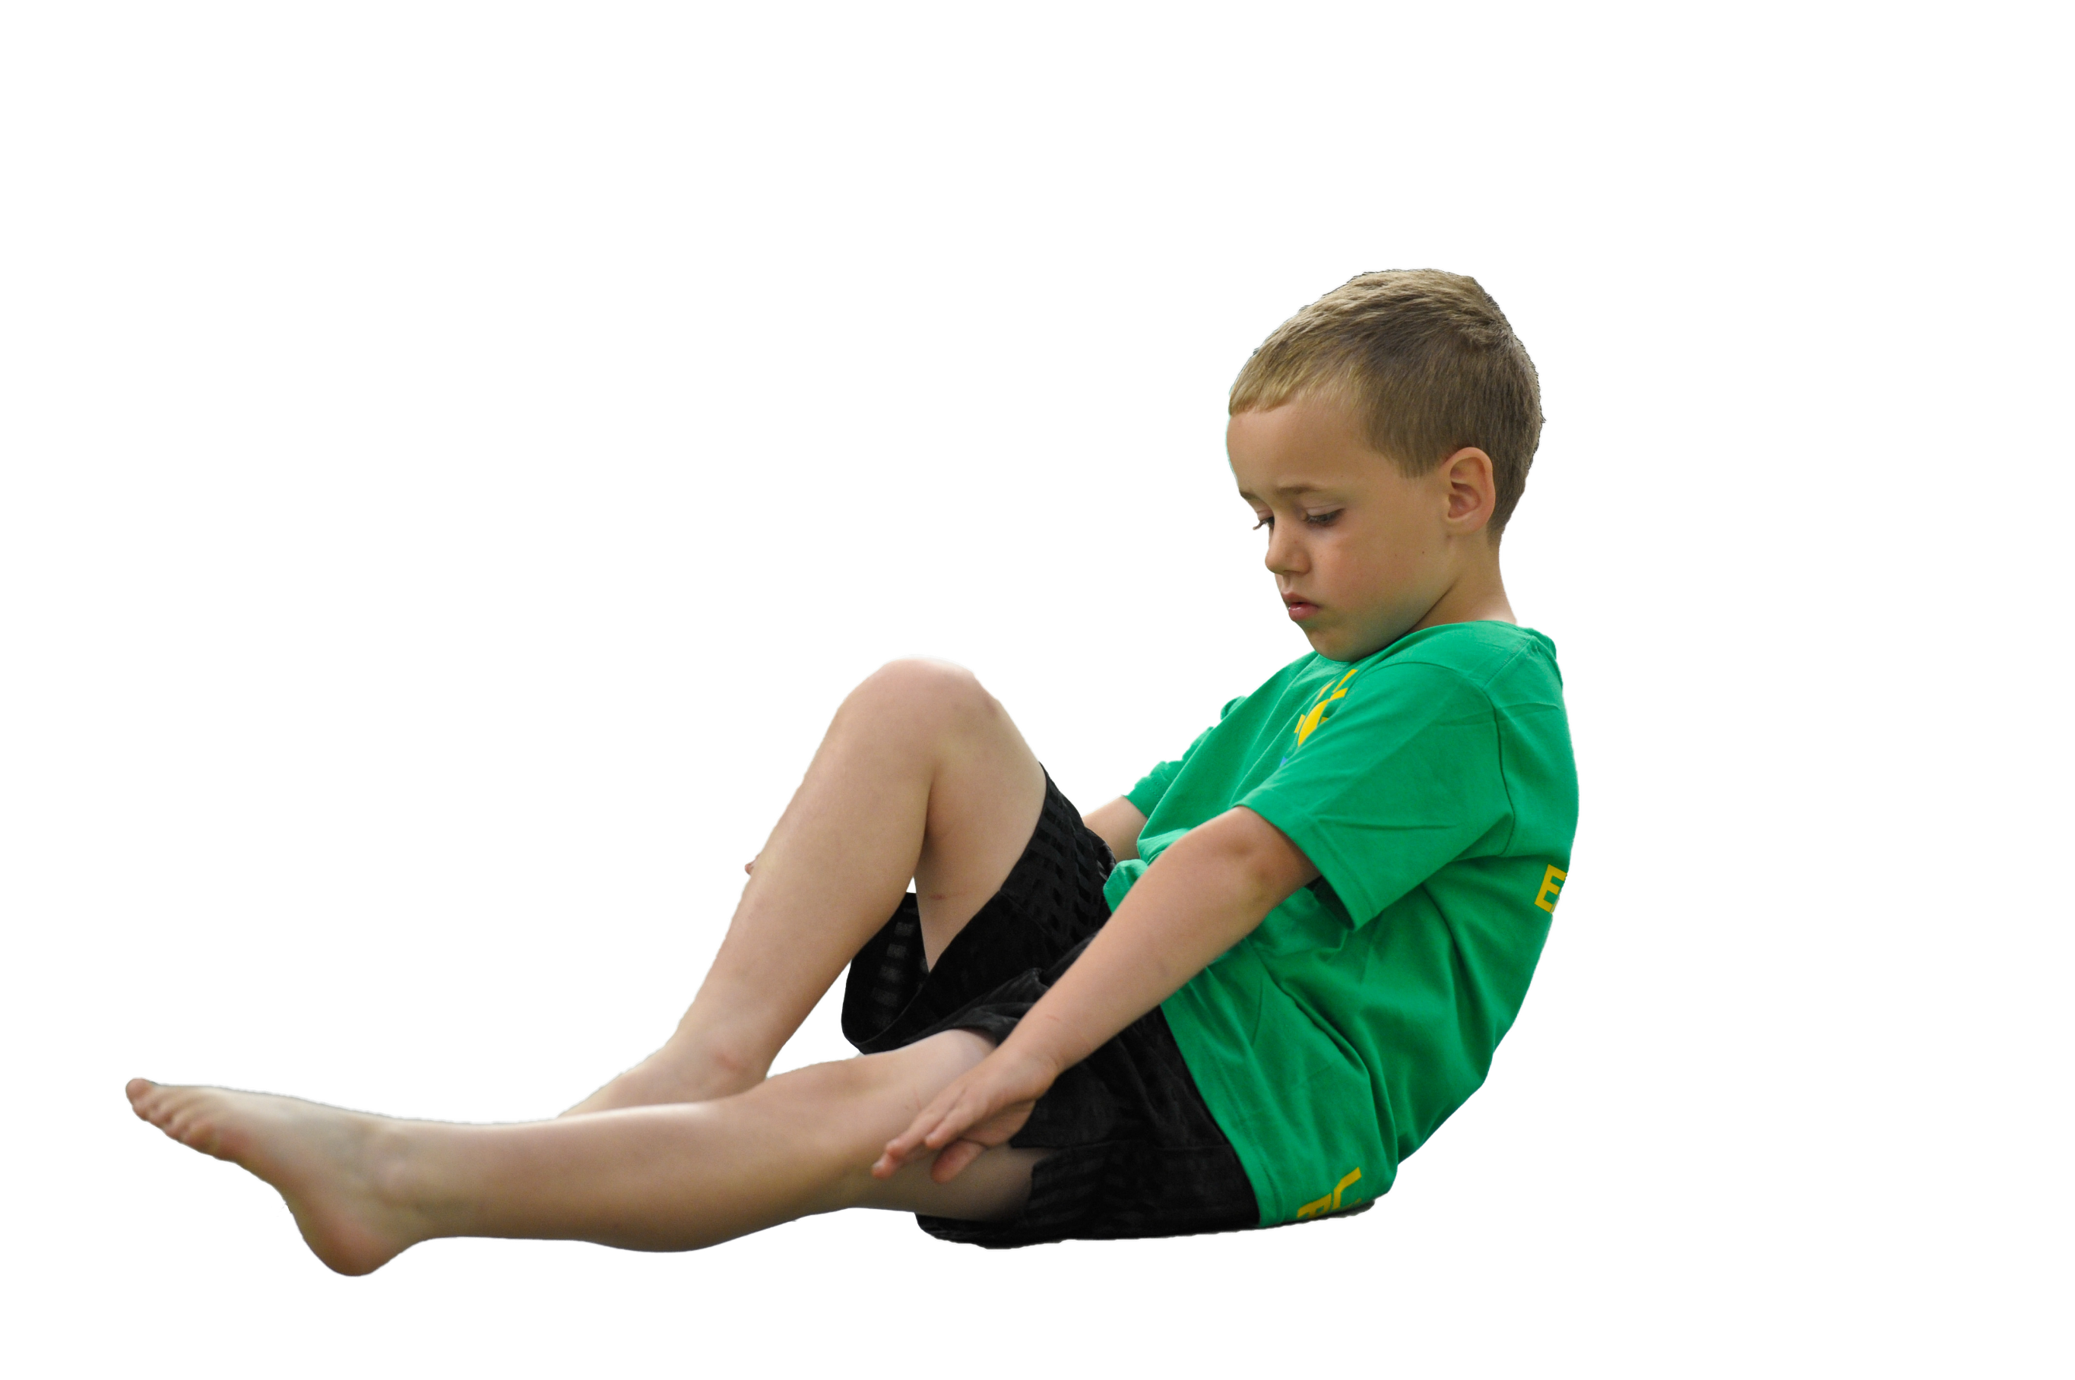
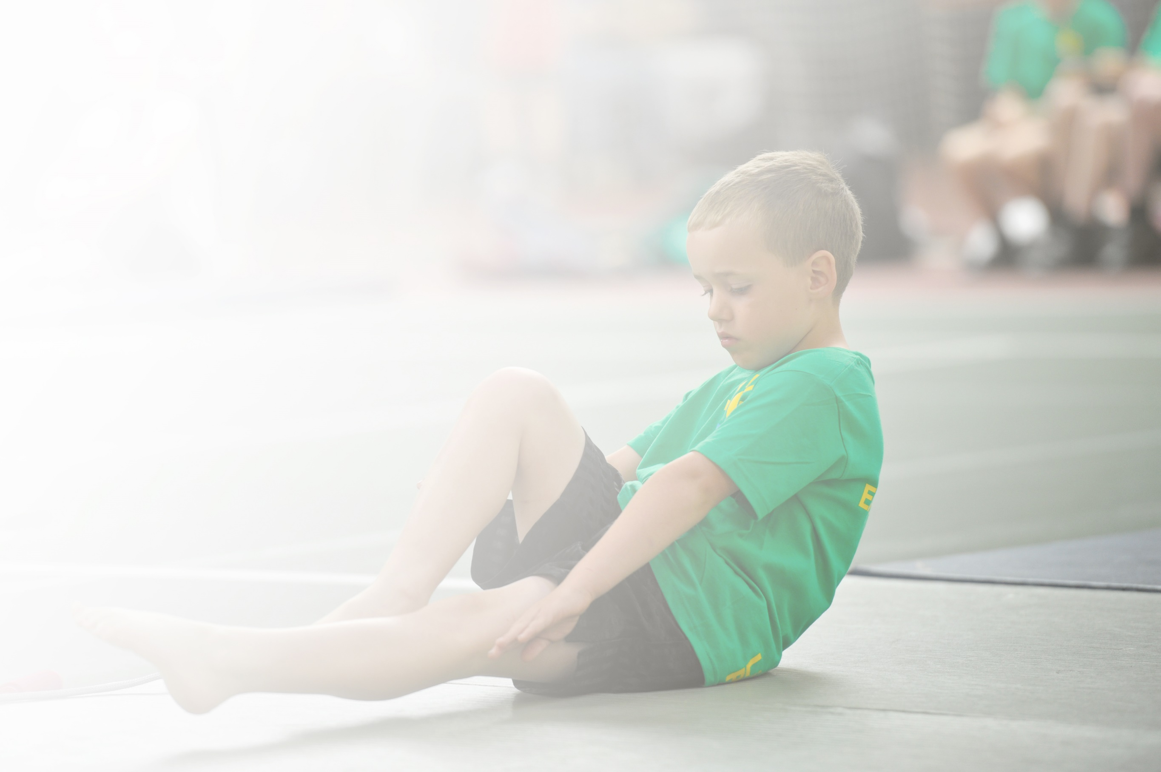
Schools must use the funding to make additional and sustainable improvements to the quality of Physical Education, Sport and Physical Activity (PESPA) they offer. This means that you should use the Primary PE and Sport Premium to:

- Develop or add to the PESPA activities that your school already offer
- Build capacity and capability within the school to ensure that improvements made now will benefit pupils joining the school in future years

Please visit gov.uk for the revised DfE guidance including the 5 key indicators across which schools should demonstrate an improvement. This document will help you to review your provision and to report
your spend. DfE encourages schools to use this template as an effective way of meeting the reporting requirements of the Primary PE and Sport Premium.

We recommend you start by reflecting on the impact of current provision and reviewing the previous
spend. Under the Ofsted Schools Inspection Framework, inspectors will assess how effectively leaders use the Primary PE and Sport Premium and measure its impact on outcomes for pupils, and how effectively governors hold them to account for this.

Schools are required to publish details of how they spend this funding as well as on the impact it has on pupils’ PE and sport participation and attainment by the end of the summer term or by 31 July 2019 at the
latest.
We recommend regularly updating the table and publishing it
on your website throughout the year, as evidence of your
ongoing review into how you are using the money to
secure maximum, sustainable impact. To see an
example of how to complete the table please
click HERE.

Support for review and reflection - considering the 5 key indicators from DfE, what development needs are a priority for your setting and your students now and why? Use the space below to reflect on previous spend, identify current need and priorities for the future.

Key achievements to date: | Areas for further improvement and baseline evidence of need:
KI 1 – all pupils receive at least 2 hours of taught PE each week, the daily mile has been successfully introduced 3 times a week, additional afternoon session – structured physical activity. All KS2 pupils wear an activity tracker and log their daily steps – raising awareness of physical activity  KI 2 – increased range of sports delivered by specialist coaches during lesson time and then extra-curricular clubs available following the school lessons. Olympian visit and SAQ session, sharing of local sports clubs.  K1 3 – all coaching sessions were supported by class teacher and teaching assistants. Valuable CPD was gained through working alongside these coaches.  KI 4 – Large range of sports offered by high quality specialist coaches.  K1 5 – Joined the Charnwood Sports Partnership later in the year and so limited participation.  School sports day is a very well attended event. | Additional space needed to deliver PE – flat playground space and cover (no on-site hall or field)  Training for lunch time supervisors  More access to competitive sport needed.  Develop outdoor and adventurous physical activity focusing on collaboration and cooperation (Forest School).  Opportunity for teacher to lead more PE sessions following the CPD from the coaches.  Continuation of high quality and addition of missing sport coaches – football and more rugby needed.  More access to competitive sport needed.

Meeting national curriculum requirements for swimming and water safety | Please complete all of the below:
What percentage of your current Year 6 cohort swim competently, confidently and proficiently over a distance of at least 25 metres?  N.B. Even though your children may swim in another year please report on their attainment on leaving  primary school. | 100%
What percentage of your current Year 6 cohort use a range of strokes effectively [for example, front crawl, backstroke and breaststroke]? | 92%
What percentage of your current Year 6 cohort perform safe self-rescue in different water-based situations? | 85%
Schools can choose to use the Primary PE and Sport Premium to provide additional provision for swimming but this must be for activity over and above the national curriculum requirements. Have you used it in this way? | Yes

Action Plan and Budget Tracking
Capture your intended annual spend against the 5 key indicators. Clarify the success criteria and evidence of impact that you intend to measure to evaluate for students today and for the future.

Academic Year: 2019/20 | Total fund allocated: £16850 | Date Updated: August 2019
Key indicator 1: The engagement of all pupils in regular physical activity – Chief Medical Officer guidelines recommend that primary school children undertake at least 30 minutes of physical activity a day in school |  |  |  | Percentage of total allocation:
 |  |  |  | 27% £4500
School focus with clarity on intended impact on pupils: | Actions to achieve: | Funding allocated: | Evidence and impact: | Sustainability and suggested next steps:
Increase purposeful activity at lunchtimes ensuring all pupils are able to access at least 30min of activity a day | Training for lunchtime supervisors  Additional session from LCFC on Monday Lunchtimes  Addition of a flat tarmacked areas at the rear of the school.  Timetabled access with SAQ activities every lunchtime | £500  Included in coaching package see below. (£4,500)  £8500  (£4500 carried over for this project from 2018-19) | All pupils accessing lunchtime activity across the school.  Zoned area for SAQ activities in new tarmac area used daily | Lunchtime staff will work alongside LCFC coach to gain skills.  CPD for lunchtime staff  Tarmac area will continue to be available to be used in future years.
We will ensure the continuation of the daily mile 3 times a week  Continuation of activity tracker wearing for KS2 pupils | Timetabled for Monday, Wednesday and Friday at 9am for 15mins  Tracker to be purchased for new year 3 pupils | £0  £100 | Regular focused activity to start the day three times a week.  Children showing increased stamina and resilience towards exercise. | Ongoing timetabling and direction from SLT

Key indicator 2: The profile of PESSPA being raised across the school as a tool for whole school improvement |  |  |  | Percentage of total allocation:
 |  |  |  | 7% £1122
School focus with clarity on intended impact on pupils: | Actions to achieve: | Funding allocated: | Evidence and impact: | Sustainability and suggested next steps:
Pupils to be encouraged to take part in competitive sports. | Children who take part in competitive sport to be recognised by the school.  School to organise in school swimming galas and to ensure sports day is competitive.  External sports teams to be invited in such as Leicester Tigers, LCFC  LCFC coach will organise matches with local schools. | See KI5 | Outside sports achievement included in newsletter.  Outside sport achievements to be celebrated in wow assembly  Increase in pupils participating in competitive sports. | Staff will be trained alongside coaches.
High quality coaching sessions led by specialists and supported by teaching staff, including after school clubs  Sporting assemblies to promote events and raise profile of the sports listed. | Book a range of outside coaches including:  Basket Ball  LCFC  Leicester Tigers  Jump to it dance  Rothley Tennis  Hinkley Gymnastics  Country Cricket | See KI4 | Plans and evaluation of coaching  -teachers to review coaching blocks  More children participating in after school clubs. | Staff will be trained alongside coaches.
Access to physical activity through the outdoor curriculum (cooperative and collaborative physical activity) – forest school | Complete build area in local spinney  Forest school level 3 training  Forest school equipment  Forest school TA support | (£500 funded from local charity)  £800 (£478 from CPD budget)  £500 (funded from local charity)  £800 | Increased outdoor activity. All children to have forest school sessions – blocks of 6 weeks | Teachers and TAs will support the Forest School Leader to develop their understanding of outdoor learning for physical activity.

Key indicator 3: Increased confidence, knowledge and skills of all staff in teaching PE and sport |  |  |  | Percentage of total allocation:
 |  |  |  | 0% within other KI
School focus with clarity on intended  impact on pupils: | Actions to achieve: | Funding  allocated: | Evidence and impact: | Sustainability and suggested  next steps:
High quality coaching sessions led by specialists and supported by teaching staff, including after school clubs | Book a range of outside coaches including:  Basket Ball  LCFC  Leicester Tigers  Jump to it dance  Rothley Tennis  Hinkley Gymnastics  Country Cricket | See KI4 | Staff will feedback that their confidence has improved. Lesson observations will show increased knowledge of sports coaching and PE teaching. | Staff will develop skills to teach better sports lessons
Key indicator 4: Broader experience of a range of sports and activities offered to all pupils |  |  |  | Percentage of total allocation:
 |  |  |  | 64% £10728
School focus with clarity on intended  impact on pupils: | Actions to achieve: | Funding  allocated: | Evidence and impact: | Sustainability and suggested  next steps:
A wide range of sports offered through lessons and afterschool clubs.  Pupils will be offered the opportunity to perform in a local dance events during their time in Key Stage 2. (jump to it festival) | Dance 12 £1,380.00 1,380.00  Athletics 6 £600.00 600.00  Cricket 6 £135.00 135.00  Tennis 9 £360.00 360.00  Gymnastics 9 £945.00 945.00  Cricket world cup 1 £250.00 250.00  Basket Ball 13 £910.00 910.00  Jo Jingles 27 £675.00 675.00  Swimming 16 £433.00 686.00  LCFC Primary Stars 44 £4,500.00 4,500.00  Rugby 6 £540.00 540.00 | £10,728 | Participation and attendance at the event  Improved attitude towards dance activities from all. | Continuation of involvement with the jump to it team  Staff will work alongside coaches to develop their skills.

Key indicator 5: Increased participation in competitive sport |  |  |  | Percentage of total allocation:
 |  |  |  | 3% £500
School focus with clarity on intended  impact on pupils: | Actions to achieve: | Funding  allocated: | Evidence and impact: | Sustainability and suggested  next steps:
School to enter local competitions through Charnwood Sports Development Service | Enter competitions  Each year group to enter 1 competition/organised event this year. | £500 | - Increased % pupil participating in inter-school competitions | Continue to work with CSDS, plan to increase the number of events attended.

