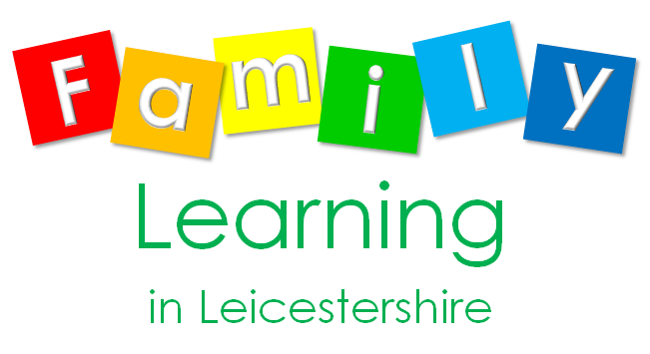

FREE course

Get Ready For School

**For parents and carers of children starting school in September**

Take part in an exciting new programme from 1st-31st July 2020.

**Now your child has a place at school, would you**

**like t**j0233953**o help and support your child to be prepared for their school journey ?**

This is a learn-at-home Family Learning course. There are 11 fun challenges to complete, using the free resources provided. You will receive your pack by post. When your child has completed all the challenges, send us the prepaid postcard and we will send your child a certificate of achievement. They can share this certificate with their teacher on their first day at school.

If you would like to enrol on the ‘Get Ready for School’ course, please contact Alison by phone or email.

Alison.Heathcote@leics.gov.uk

Text or phone 07535 641845.



FREE course

FREE course

FREE course