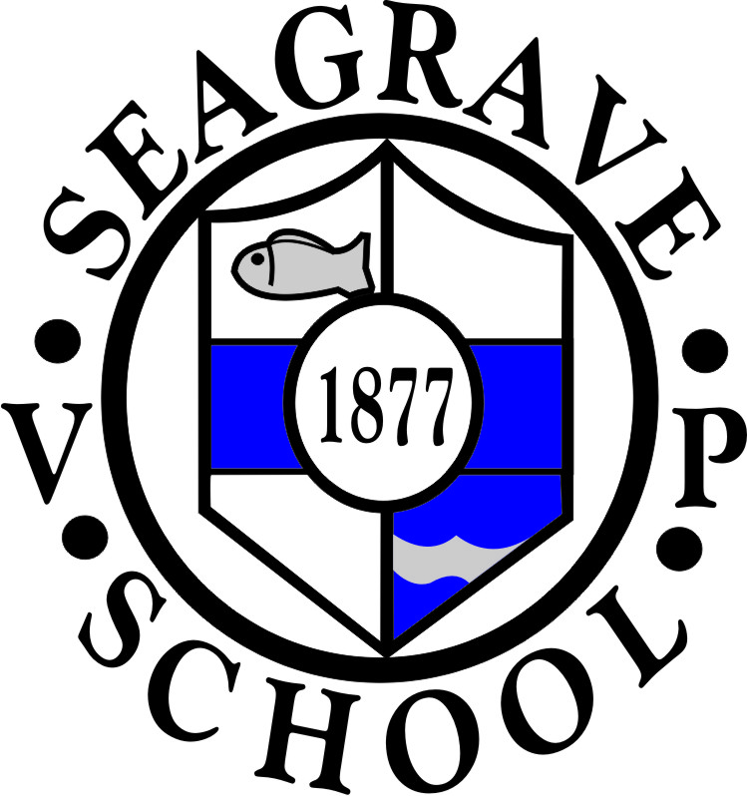

IMPORTANT NOTES

Administration
It is a requirement to have sight of a child’s birth certificate upon starting school. Could you please bring a copy into school with the admissions form.

Milk
Cartons of Semi Skimmed milk are delivered to school for children. Milk is free until your child’s 5th birthday and is available through the Cool Milk Scheme. After their 5th birthday your child’s milk can be paid for. Further details are available from Cool milk.com. All children will have been registered, please let us know if your child does not wish to have milk.

Free School Meals/Pupil Premium
Following the Government Universal Infant Free School Meal initiative a hot meal is provided free of charge for pupils in EYFS, Year 1 and Year 2. However, if Parents are in receipt of qualifying support (please see enclosed leaflet) they can also apply for Free School Meals from Leicestershire County Council which would also enable pupils to receive Pupil Premium (leaflet enclosed) which is additional funding to be used in school for their support.

Day to Day
- Administration of Medicines – Please be advised that no medication can be given in school without a completed request form
- PLEASE BE ADVISED THAT IF YOUR CHILD HAS BEEN SICK OR HAD DIARRHOEA AS RESULT OF A BUG, OUR SCHOOL POLICY IS THAT THEY SHOULD BE KEPT AWAY FROM SCHOOL FROM A FULL 48 HOURS FROM THE LAST EMISSION.
- Please note that we have children who have nut allergies so we are a NUT INTOLERANT school. Please check the ingredients in items that you send in to school.
- Children are allowed to have a piece of fruit at break time, but NO sweets or chocolate bars. Fruit is currently provided free of charge each day for children until the end of Year 2 by the National School Fruit and Vegetable Scheme.
- Following the Government regulations a hot meal will be provided free of charge to all children starting in Foundation Stage, and currently will continue until the end of Year 2. We would strongly recommend that parents take up this offer.
- We would ask that children are sent to school with Velcro fastenings on their shoes whenever possible. As you can imagine it takes a long time to fasten many pairs of shoelaces!
- Children should not wear earrings for school on P.E. days. If they are unable to take them out for any reason, then they should bring a roll of micropore so that they can be covered.

If you have any queries, please ask!

