Seagrave Village Primary School

Early Years Foundation Stage

Parents’ Information
Welcome to the Early Years Foundation stage (EYFS) at Seagrave. This booklet is intended to inform you of some of the activities, procedures and entitlements which your child will experience during the year.

Our teaching and learning programme in the Foundation stage is based on the four principles of effective learning;

The Unique Child
Every child is a competent learner from birth who can be resilient, capable, confident and self-assured. We encourage children to be independent and willing to “have a go”. They are all unique and so we, at Seagrave, provide a curriculum that is individual to their needs and learning styles.
Positive Relationships
Children learn to be strong and independent from a base of loving and secure relationships with parents and/or a key person.
As soon as the children enter the setting we give them lots of opportunities to develop positive relationships with their peers, the older pupils and with adults in school. The adults in Foundation stage will be Mrs Chafer (EYFS lead) and Mrs Walker (Teaching Assistant)

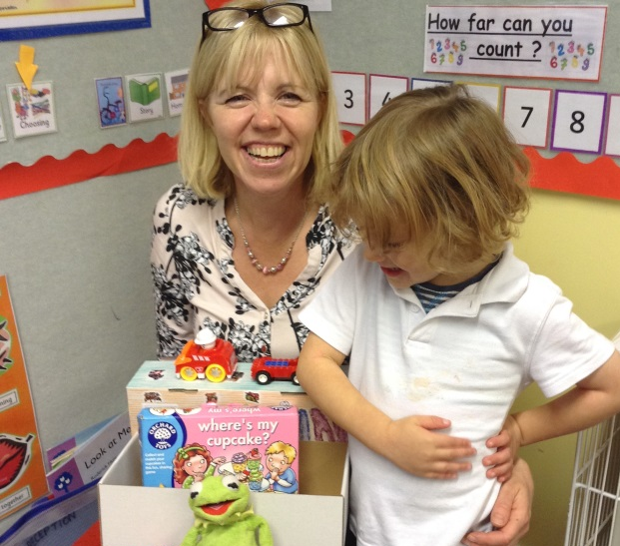
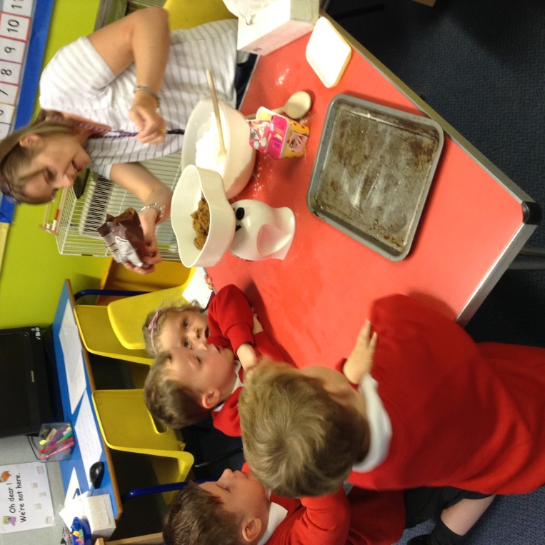

Enabling Environments
The environment plays a key role in supporting and extending children’s development and learning. At Seagrave the classroom is arranged to give children opportunity to explore and develop their learning and activities their own way. The children will engage in both adult guided activities and also child initiated activities. They will have daily access to our outdoor classroom where they can continue their learning on a larger scale.

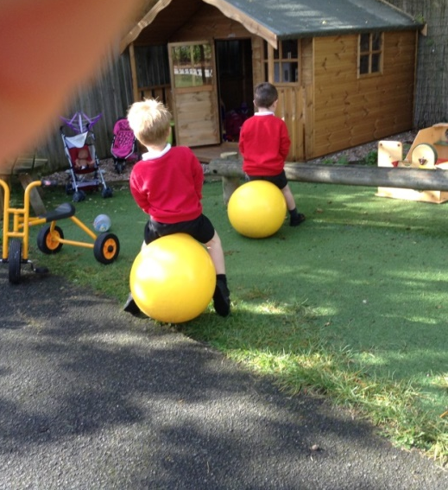
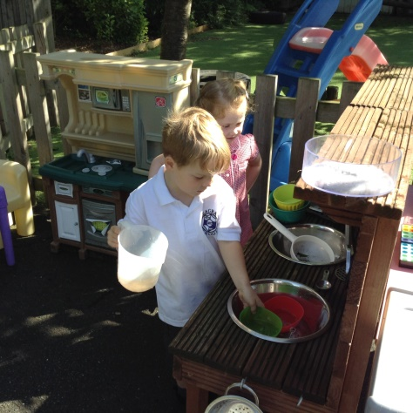
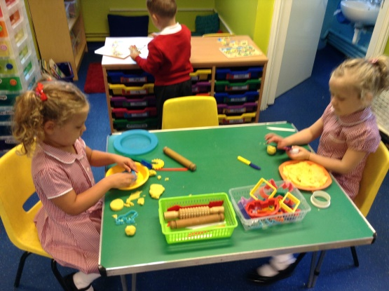

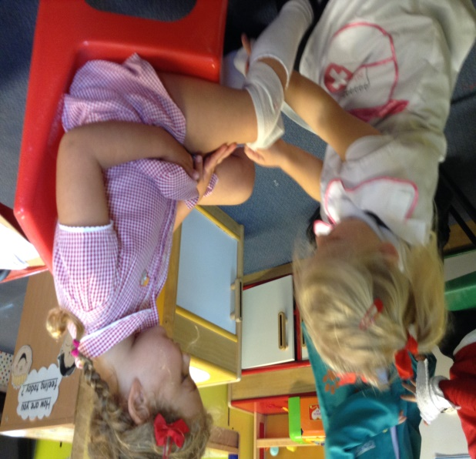
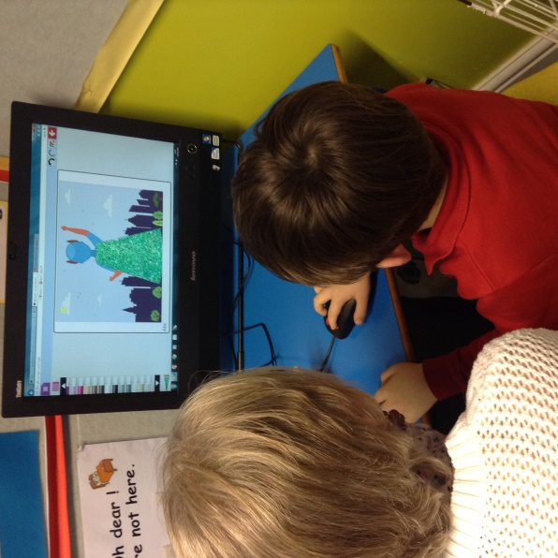
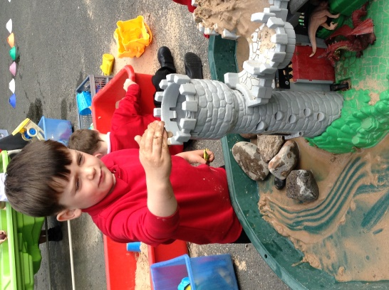

Learning and Development
Children develop and learn in different ways and at different rates and all areas of Learning and Development are equally important and inter- connected.

Your child will experience a range of exciting and stimulating activities based on themed topics and their own interests. The children are encouraged to select their own learning situations and resources both inside and in the outdoors area. Their progress will be tracked via their own personal ‘Learning Journey’.
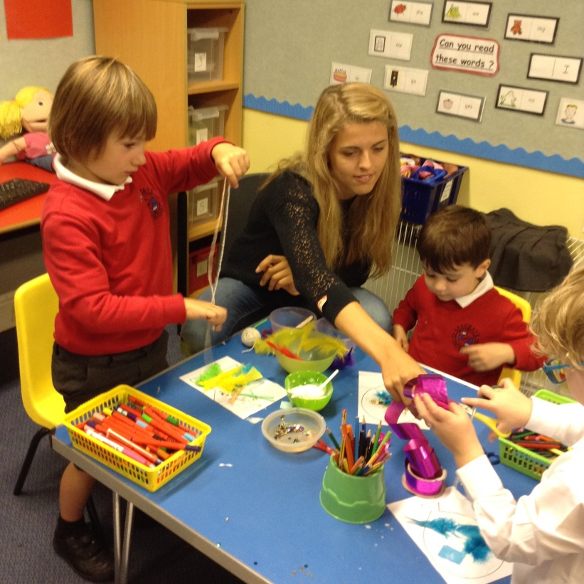
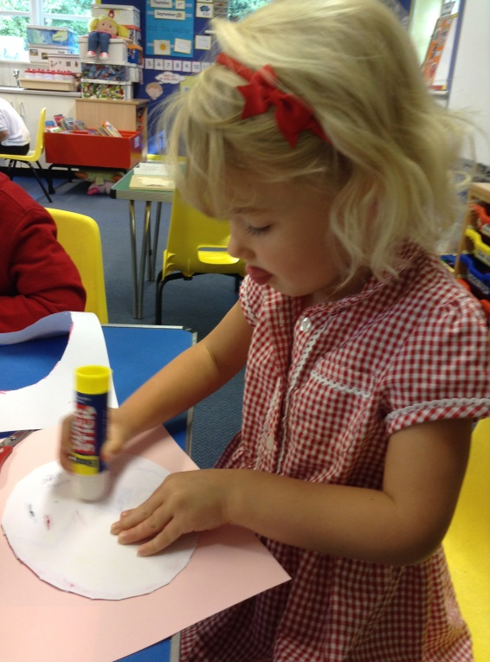

Assessment
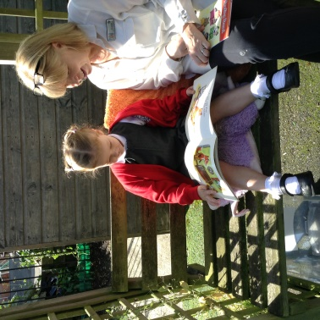
Your child will be assessed within the first 2 weeks of starting school to enable us to plan appropriately for their learning and development. Assessment is an ongoing process throughout the year.
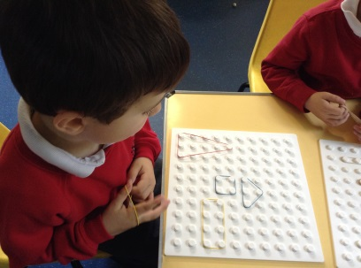

Staffing
The Foundation Stage unit is led by Mrs Maxine Chafer who is also ‘Deputy Head’. Mrs Chafer is supported by Mrs Walker each morning. All of our staff are highly experienced and dedicated. They work hard as a team to ensure your child is settled, happy and motivated to learn. Please feel free to talk to Mrs Chafer about your child’s progress or any questions you may have.
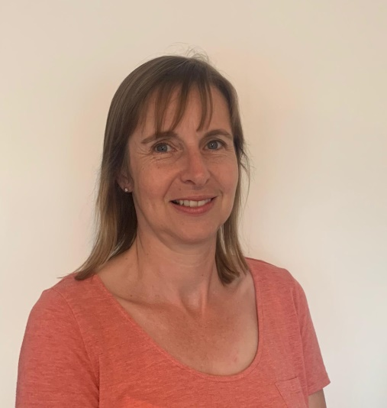

The school hours.
Our day starts at 8.50am. The gate is opened at 8.45am. EYFS children and parents can make their way straight into their classroom where teachers will be ready to receive them. It is very important that your child arrives promptly so that they do not miss out on essential learning time. Lateness and attendance is monitored. The school day ends at 3.30pm. Parents and carers are asked to wait in the school playground not on the pavement, until the class teacher releases children to parents directly. Please inform Mrs Chafer or Mrs Walker if a different person is collecting your child.

Playtimes and Lunchtimes
There will be many opportunities during each day for your child to experience outdoor play and learning in line with the guidance for the Early Years Foundation Stage. In addition to this, the children will be encouraged to join in with playtime with the other children in school. They will be supervised at all times and will be able to experience our Jungle Trail when the weather is fine.

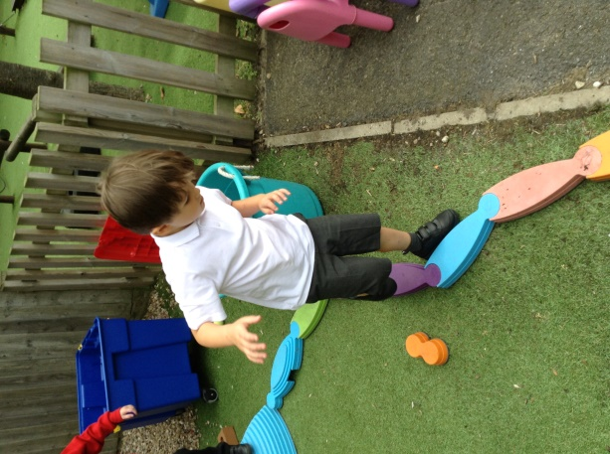
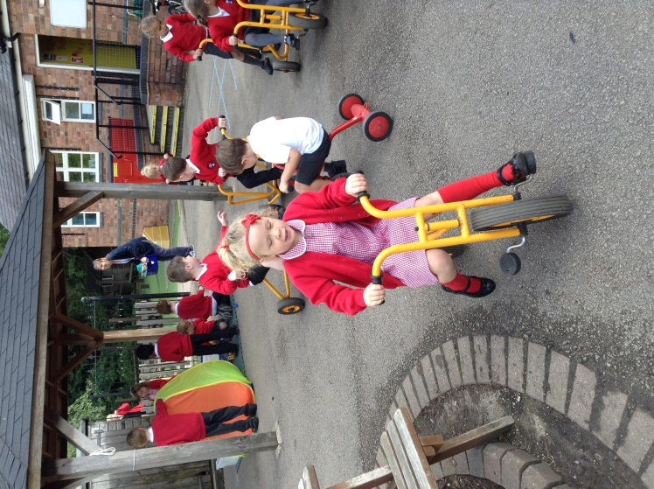
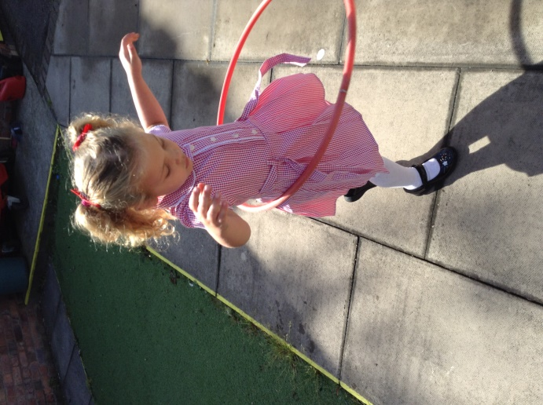

Lunchtime
Parents will have the choice of hot meals (which are free of charge in EYFS and Key Stage 1) or packed lunches for their children when they start school. After lunch they will be able to play with their friends until we start the afternoon sessions at 1.10pm.

‘School Rules’
In line with the rest of the school, there are ‘School Rules’ which the children are introduced to, and follow, and which encourage good behaviour and respect for themselves and others.
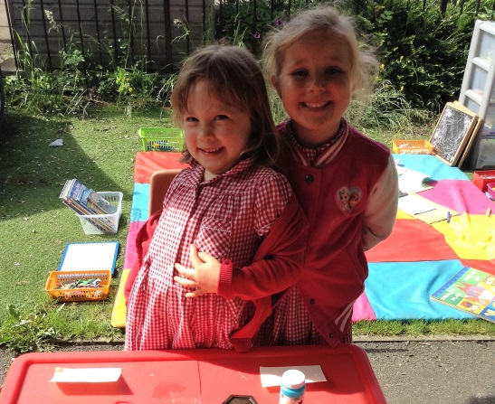

Parents
Throughout the year parents will be invited to join the children in the Foundation stage for various activities. Details will be sent out to parents nearer the time. Staff are available at the beginning or end of the day to address any questions or concerns you may have or if you need a longer chat then please make an appointment with Mrs Chafer so that we can give you the time you need.

