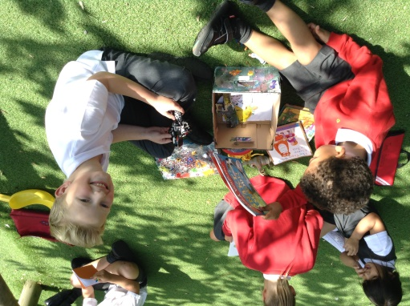
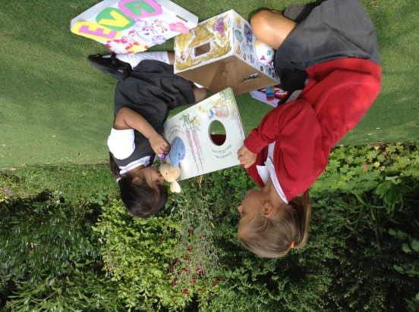

Treasure Boxes!
Over the next few weeks we would like you and your child to create their very own box of treasures!
Find an empty shoe box (or similar) with a lid. We would like you and your child to decorate it. They may want to paint it or stick stickers onto it or cover it in bright wrapping paper – follow their lead!

Then we would like them to fill it with things that are special to them. These could be a favourite toy, a book, some photos etc.

We would like your child to bring their treasure boxes with them when they start school in August. We will keep them in school for a few days and every child will get the opportunity to share their treasures with their new class mates. It is a great way of all of us getting to know each other.

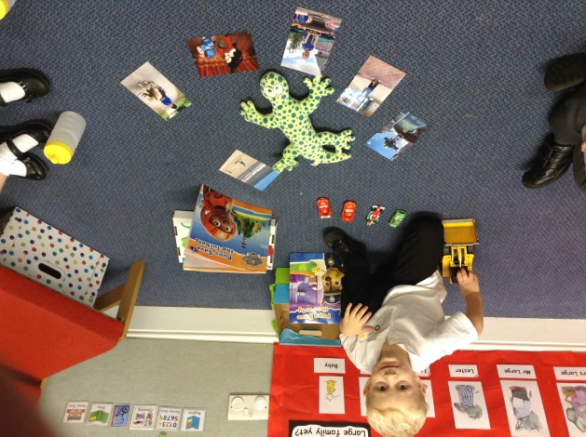
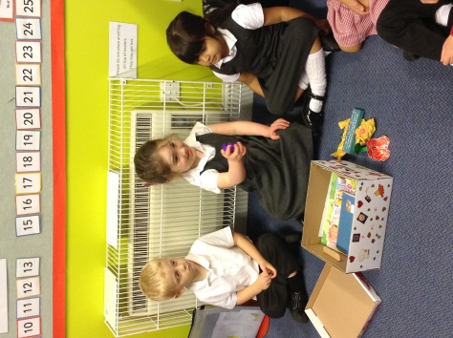
We hope you have fun preparing them with your child and we look forward to seeing them in August.

