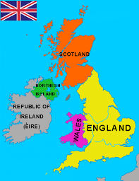
Welcome to our Summer Term Newsletter for Class Two!
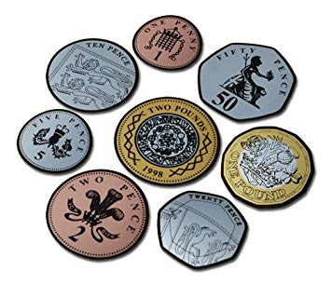
The term has already begun and we have started our new topic on the United Kingdom. We are learning about the key geographical features of the United Kingdom along with a local study about where we live. In English we have written letters to The Queen and used atlases and other non fiction texts to gather information. We have also been learning about Money and Measures in maths and making real-life links. Several children have already brought in lots of ‘Show and Tell’ items relating to these topics which we all enjoy.

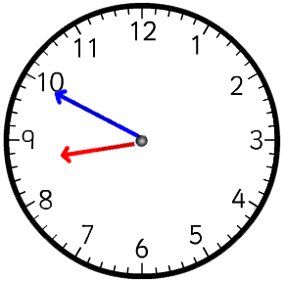
A Few Reminders:
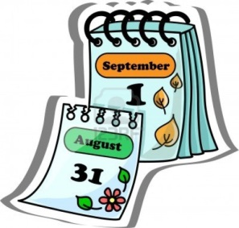
Please ensure that pupil absence is rung into school before 9am when the registers are closed.
Thank you for ensuring children are on the playground from 8.45 and in class by 8.50am.
Please ensure that your child has their PE kit in school every day.
We appreciate that the weather is very changeable at the moment so please ensure your child brings a coat if rain or cold weather is forecast and a sunhat if hot weather is forecast. PLEASE name all items of clothing as these items can be difficult to identify.

Keep your eye on ‘weduc’ as this has all notices and diary dates you need for the term.
Monday | Tuesday | Wednesday | Thursday | Friday
Reading Book | Reading Book  Recorders  PE | Reading Book  PE | Reading Book | Reading Book  Spelling Test

