Wednesday 8th September

FAO All Parents/Carers of Bradgate Education Partnership

Dear All

Re: Covid update

As we come towards a fortnight back in our schools I am writing to update you on the situation across the Trust.

Firstly, I hope you and your child have had a safe and successful start to the Term. All of our schools re-opened as planned and they were full of the energy and optimism you would hope to see at the start of the year. Our students made a fantastic start and the schools have been a pleasure to visit.
However, very disappointingly over the last 7 days we have seen high numbers of positive Covid 19 cases in a number of our schools. Therefore, I am writing to you today to try to outline the context and keep you informed about the situation.

As you are no doubt aware the government has dropped the guidance requiring schools to operate bubbles or requiring pupils to isolate when there is a case of covid within a group. We also feel that you need to be aware that due to this we are being advised that we must keep the classrooms open even on the occasion of multiple cases – in one of our settings over 50% of the class tested positive within 3 days and we were advised to keep the class open. As this is such a significant shift in policy we wanted to be clear with you about the information and direction we are being given from the government and Public Health bodies.

We understand that many of you will be anxious about sending your child into a setting where there are high case numbers present, whilst others will feel that the return to normality and keeping classrooms open is paramount and trumps any risk. Clearly, we are trying to balance both of these views: keeping our classrooms open where possible but also ensuring our students and staff are safe.
Therefore, where we experience high case numbers we may need to take a few additional steps in order to retain as much normality for our students as possible. We will, of course, keep trying to communicate with you about all of these steps throughout or regarding any changes in guidance or policy.

Our sense is that we are facing another extremely challenging Autumn and Winter across our schools during which we will endeavour to do all we can for our students. Please can we ask for your ongoing patience and support.

Yours Sincerely,

Gareth Nelmes Dean Pomeroy
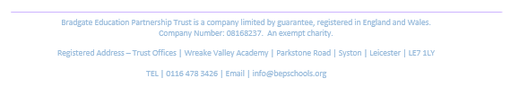
Chief Executive Officer Director of Schools

